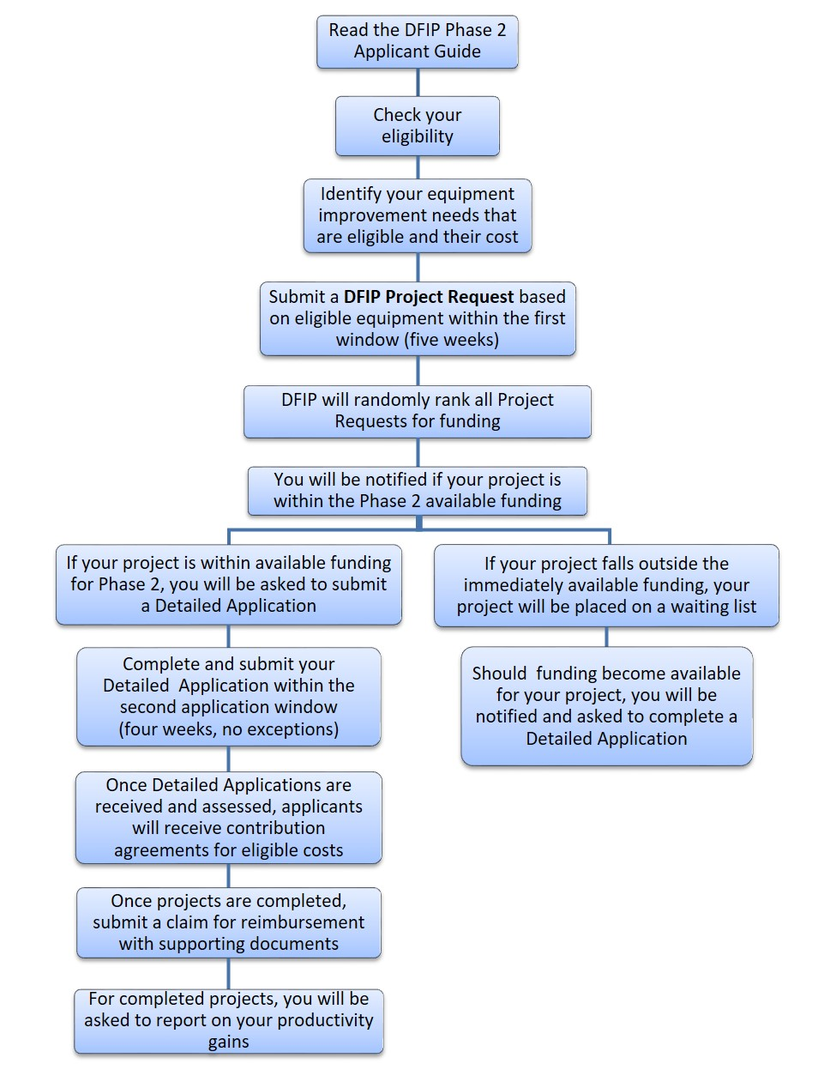
DAIRY FARM IMPROVEMENT PROGRAM FLOWCHART- Phase 2 (from DFO website)

Phase 2 of the Dairy Farm Investment Program (DFIP) is underway. As you recall, this is part of the governments attempt to compensate dairy producers for concessions that were made as part of the Canadian-European Trade Agreement (CETA). There is approximately 129 million dollars available across Canada in phase 2, of which Ontario is eligible for 43.22 million.
Your DFO website has posted a detailed summary of the differences in Phase 1 and Phase 2 application process. This time there will be a two-step application process to better allow all dairy farmers a fair chance of applying. Step 1 is a pre-selection process, (Jan.7/19 - Feb.8/19 ), where all producers interested must submit their intention to apply. This eliminates all the paperwork that you had to do under Phase 1 prior to finding out if you were even selected for funding. After the closing date of Feb.8/19, there will be a random draw from all applicants. No more hovering over the ENTER button on your keyboard, waiting for the application window to open!
Preference will be given to producers that did not receive funding under Phase 1. If you are chosen in the random draw, you will be notified, and you must acknowledge your intention to continue to the second step. You will have four weeks to gather and submit all the relevant information regarding your project.
Interestingly, projects that were started on or after Aug.1, 2017 and even completed, are still eligible for funding. There will be a max. of $100,000 compensation per project with up to 50% of project cost reimbursed. From the DFO website, there is a link to Annex A “Eligible Equipment Types”, which is a very lengthy list of in-barn only equipment that is eligible for reimbursement, including lighting, manure scrapers, alley mats, straw choppers, positive pressure tubes for calf barns etc. Used equipment is ineligible for compensation.
The flow chart below comes from the same website and is a good summary of steps to follow. In this era, where our governments are giving up dairy concessions in their trade agreements, you might as well take advantage of any reimbursements that come our way, particularly if the projects were in the planning stages anyway.
Happy New Year to all! Let’s hope 2019 gives us a truly unbiased revamp of the Canadian Food Guide, recognizing the value of dairy products in a healthy diet, continued efficiencies on your farms, and good health!

