What does it cost to keep that heifer?
This topic has garnered a lot of interest lately. Not only is the cost of raising a heifer important, also important is the number of heifers raised. Compared to past decades, we now have much improved transition cow management, superior nutrition, and have made significant reproductive advancements which have improved fertility measurably. Sexed semen usage is very common especially in heifers. Cull rates of 30-35% primarily due to poor fertility are much less common. These factors have contributed to an excess of heifers on many farms. Pregnancy rates greater than 18-20% will typically provide more replacement heifers than needed. The Ontario median pregnancy rate is 16%.
Many herds have expanded recently, largely due to quota increases and additional incentive days. The result has been larger heifer inventories and crowded facilities. Environment and competition both play big roles in heifer growth and health. Too many heifers can put growth and health at risk.
How many heifers do you really need? There are several factors that determine the answer to that question. They are:
Number of heifers born Number of heifers needed
Herd size Herd size
Age at 1st calving Age 1st calving
Cull rate % Heifer percentage
Heifer non completion % Calving interval
(% of heifer calves that don’t make it
to the milking herd) Heifer mortality rates

A 100 cow dairy with a 30% cull rate, a 10% heifer non completion rate and 24 month age at 1st calving (AFC) only needs 33 heifers calving per year to maintain herd size.
A 100 cow dairy with a 13 month calving interval, a heifer percentage of 50%, a calf/heifer mortality rate of 5% and AFC 24 months will generate 44 heifers per year.
Both scenarios are very attainable.
AFC and heifer health are big drivers in determining how many heifers are needed on any farm.
Heifer rearing costs vary considerably but current Ontario averages are in the vicinity of $2500 and can be between 15-20% of total farm expenses. Feed costs make up the biggest portion at 50-60% of total costs. The most expensive per day feed costs occur during the first 6 months of life (milk or milk replacer costs plus calf starter / grower supplements). Feed costs in this group are difficult to reduce. Protein and energy should not be underfed. In general, milk replacer is a cheaper option than whole milk, unless there is a milk surplus on farm or an excess of unsaleable milk. All milk fed to calves should be pasteurized.
Forage analysis is important for post-weaning heifers. High quality, palatable feeds are necessary. Some forages make excellent heifer feed. For example, male sterile non-BMR forage sorghum is an excellent forage for heifers over 4 months of age. Protein levels average 12-14%. Harvest timing affects energy concentrations. Heifer groups need to be monitored for weights and body condition score. Weighing heifers is an important tool to ensure that average daily gains are around 0.8 kg/day before 12 months of age and around 0.9 kg per day afterwards until calving.
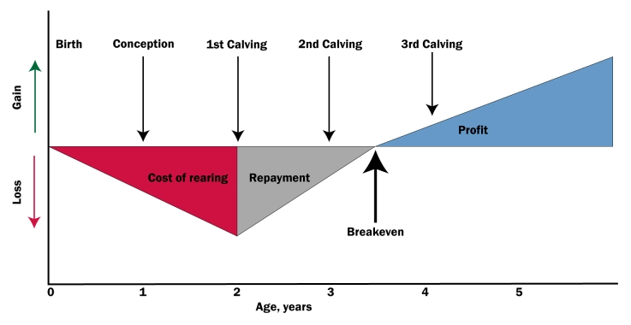
Labor costs typically account for about 12-15% of heifer raising costs. Heifers managed per hour ranges from 6-20 with an average of 10 for pre-weaned calves (6 minutes/calf/day) and a range of 40-100/hour with an average of 60 in post weaned heifers (1 minute/heifer/day). These values largely reflect economies of scale. There are always labor efficiencies to be found. Whatever you do to improve these efficiencies will help reduce costs. This can’t be at the expense of results. Heifers should never be overlooked or undermanaged.
This graphic was copied from an ABS article “Hidden costs of raising extra heifers”. The graphic demonstrates that heifers typically become profitable sometime early in the 2nd lactation.
If you sell dairy replacements near the time of calving, you need to be paid at least $2500 - the cost of rearing. If you presently have too many heifers, we strongly recommend that you make the decision to sell the excess replacements as calves, AND that you breed more of your cows and/or heifers to beef. Beef on dairy breeding is becoming very common. An 8-10 day old beef cross males are fetching around $430 and week-old beef cross females are bringing around $330. Holstein bull calves average $100, but often bring much less. Shouldn’t they become a thing of the past. Increased usage of beef on dairy will relieve facility space, reduce feed inventory requirement, reduce labor needs, and provide more income.
How many heifers per month do you need to calve each month to maintain milking herd inventory?
AFC is a key factor in the number of heifers needed. AFC data from Lactanet 2021 was 26 months for herds in the 25th percentile and 23 months for herds in the 90th percentile. These 3 extra months require extra feed, extra inventory, extra facilities, extra labor without any milk revenue. The benefit to the herds in the 90th percentile is huge compared to the herds in the 25th percentile. Well grown heifers can calve at 22-23 months of age without sacrificing milk production. In fact, Lactanet 2021 results show heifers calving between 22-23 months produce more 305M than their herd mates.
Let’s compare a herd with AFC of 23 months to a herd with an AFC of 26 months:

3 extra months to 1st calving:
 | Cost/ Lost Revenue | Total Cost
90 extra days feed costs at $2/ day pre-calving | $180 | $180
90 days lost milk revenue  *33 litres/ day at $0.80 / litre | $2376 | $2556
90 days milking feed cost $12/ day | -$1080 | $1476

A herd calving heifers at 23 months of age should be about $1500 per heifer ahead of a herd calving at 26 months ($500/ month advantage).
Assess your operation, look for efficiencies, and only raise and breed the number of heifers required. Please speak with your veterinary advisor on the best way to manage your heifer inventory.

PLEASE NOTE THAT THE EMAIL FOR ETRANSFERS HAS
CHANGED TO: navanvs@nva.com

