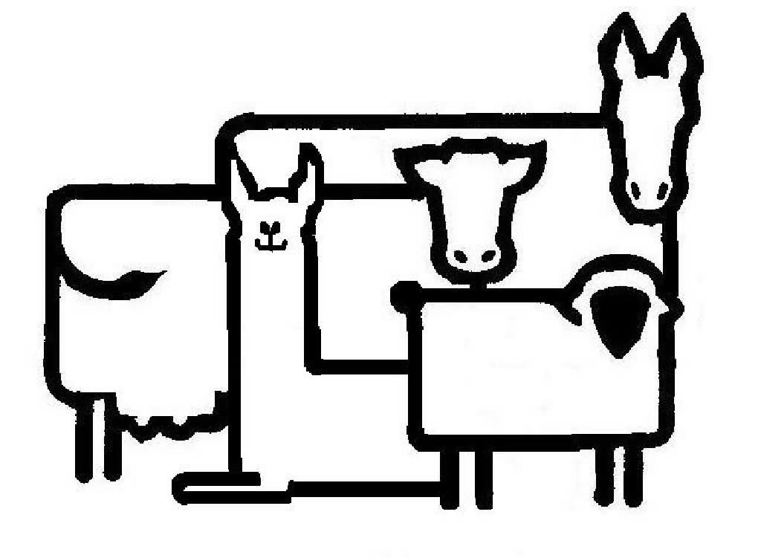
Navan Veterinary Services

Infectious Bovine Keratoconjunctivitis (Pink Eye)

Every summer, starting in July and worsening in August and September flies become a major issue and with them comes Pink Eye (PE). PE is an extremely contagious disease which causes inflammation of the eye. PE is a very painful condition and as a result can cause decreased weight gain in calves and heifers, and decreased milk production in lactating cows.

Cause
It is most commonly caused by the bacteria Moraxella bovis. The bacteria is a normal inhabitant of the tissues around the eye and typically causes disease when the animal is stressed or the eye is damaged. Such damage can occur from particles in the air such as dust and other debris, and from intense sunlight. Cattle with white faces such as Herefords, some Holsteins and light coloured beef breeds such as Charlois are especially sensitive to sunlight. The glare decreases their immunity to Moraxella. PE is more common in calves and youngstock as they have not yet developed immunity to the bacteria.

Clinical Signs/ Diagnosis
The diagnosis is based on clinical signs, the location of the lesion (always in the center of the cornea [eye]), the time of year and the presence of flies. The disease can be broken down into stages.

Stage 1 | Stage 2 | Stage 3
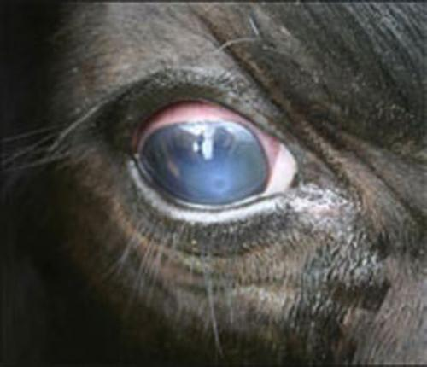  The initial signs include tearing, increased blinking, eye redness and sensitivity to light. A decrease in DMI and subsequently production may be seen as a result of pain. A small white ulcer begins to form in the eye. | 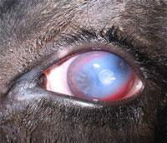  As the disease progresses the ulcer continues to spread in the cornea and the entire eye becomes cloudy due to the inflammation inside the eye. The eye looks red as it attempts to heal. | 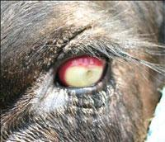  As the ulcer and inflammation continues to spread; it affects the inner parts of the eye. The continued damage gives the eye a yellow appearance. At this stage the damage done to the eye can be irreversible and can cause vision loss.
Merck Veterinary Manual

Prevention
The most important aspects of prevention are 2-fold: control fly populations in the environment; keep flies away from the eyes of cattle. Flies spread PE. We can’t eliminate all flies, so we need to find a way to minimize their numbers. During the summer, the life cycle of the fly is accelerated and an egg can become an adult within 7-10 days. Fly numbers are best controlled by:
- good air movement (ventilation)
- removal of manure and organic forms of bedding once per week, particularly bedding packs. For hutches, we recommend bedding with sand in the summer and early fall. In indoor calf pens we recommend sawdust or shavings instead of straw.
This will help keep fly numbers lower in the barn, reducing the need for fly repellent products. There are sprays for barns however many are not licensed for lactating cattle and therefore we discourage their use.

Fly Control Products
Product | Usage | Efficacy | $/ cow for season  *Assumed to be 4 months beginning in June unless otherwise stated  *Assumed for a 1500 lb cow | Cost | Withdrawals
Cylence | Repeat every 4 weeks  Maximum of 3 treatments  12ml/ cow | High | $3.00 per treatment  *3 treatments  Total: $9.00 | 500ml: $124.68  3L: $672.98 | Milk: None  Meat: 1d
Boss Pour-On | Repeat every 4 weeks  3ml/100lb  Maximum dose of 30ml | High | $1.08 per treatment  *4 treatments of 30ml each  Total: $4.32 | 900ml: $32.09  3.78L: $124.60 | Milk: None  Meat: None
Fly Tags (Saber) | Place 1 tag/ear (2 tag per animal) for 5 month fly control | Average | Total: $12.50 | $125.00 for 20 tags (10 animals) | Milk: NOT for lactating cattle  Meat: None
Solmectin | Effective for up to 35 days after treatment  4.5cc/100lb | High | $2.74-5.59 per treatment  *4 treatments  Total: $10.96- 22.36 | 1L: $82.88  4L: $162.51  10L: $369.08  20L: $650.29 | Milk: NOT for lactating cattle  Meat: 49d

For pastured cattle (primarily beef herds), prevention includes ensuring proper pasture management including trimming the pasture to keep the seed head off the grass, and providing shade from the sun, both of which will minimize eye irritation.

Treatment
In NON-LACTATING cattle; (calves and heifers) you can use Oxyvet LA given at the label dose of 1ml/ 20lb (4.5ml/ 45kg or 100lb). It is always advisable to also give a dose of pain medication such as Metacam at the same time.
LACTATING cattle can be treated with an injection directly into the eyelid by a veterinarian. A combination of 2cc Eficur (previously Ceftiocyl) and 1cc Predef (isoflupredone acetate) mixed together is extremely effective. The withdrawals for milk and meat are 72 hours and 5 days respectively.Again, we do recommend pairing with an NSAID such as Anafen or Metacam for pain relief.
Eyes are very slow to heal. The healing time is directly proportional to how advanced the PE lesion is at the time treatment is initiated. Generally, PE is detected around Stage 2. Once appropriate treatment has been implemented, we can expect tearing and blinking to decrease significantly in the first week. The eye will still be very white at this time. Over the following weeks to a month, the white cloudiness will slowly lessen. A Stage 2 lesion typically takes around 2 months to heal.

An ounce of prevention is worth a pound of cure. To ensure that we maximize the health of your cattle, please discuss your fly control as well as pinkeye prevention and treatment plan with your veterinarian.

